MORE COLLABORATION
IN WORKBOAT WORLD
Wanted or Needed?
by
Captain Henk Hensen FNI FITA

Introduction
Why are there photos of aircraft and greenhouses in an article written for the Workboat industry? Let me explain. The whole workboat industry is a competitive business. This has several advantages in our open economy, but also a number of drawbacks. Below the pros and cons of the competitive market of the present tug industry will be considered as an example for the whole workboat industry and the value of higher levels of collaboration in promoting more cost effective and safer working practices as well as a higher degree of innovative developments will be explored. The Airline industry and Greenhouse horticulture sector will therefore be used as two informative examples.

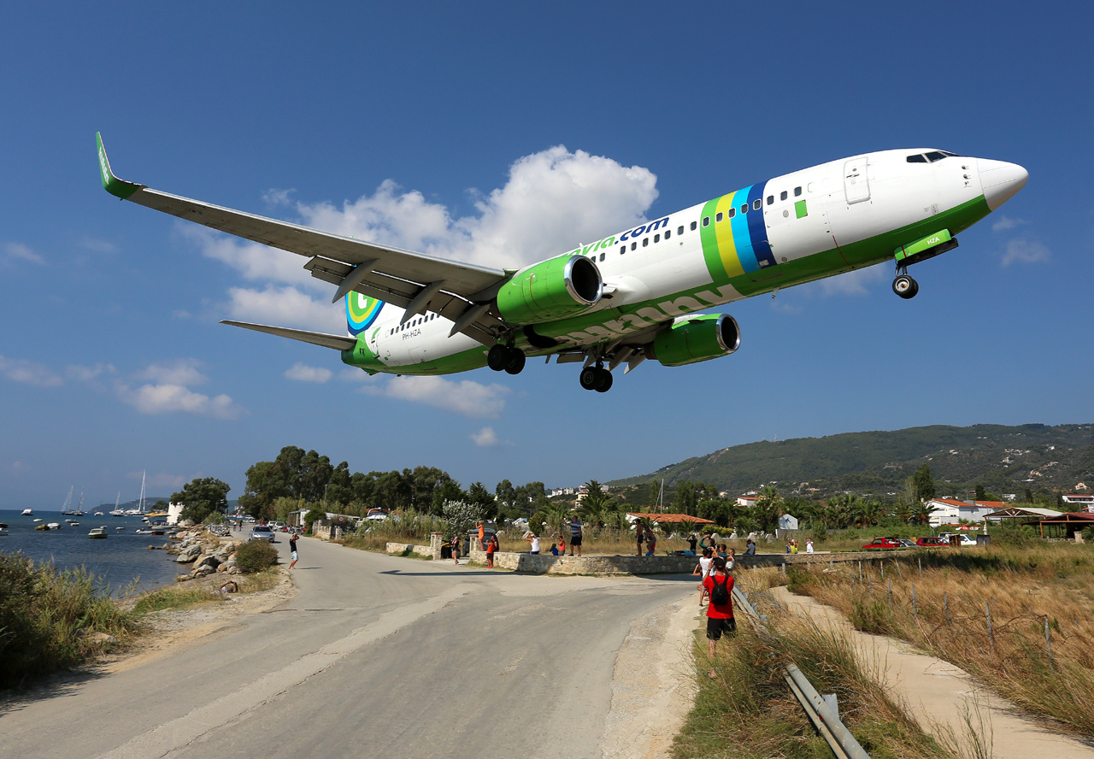
Timo Breidenstein - http://www.airliners.net/photo/Transavia-Airlines/Boeing-737-8K2/2489854/L/
Pros and cons
Inherent to a competitive market is the fact that production costs and consumer prices are continuously under pressure. This can be experienced almost daily for instance in the various supermarkets. The situation for the tug industry does not differ.
Towage companies can look around for the best price for a new vessel, equipment, fuel, ropes, etc. or can bargain about a lower price, while stakeholders -such as shipping companies- follow the same strategy, and try to arrange suitable tugs for their ships calling at the port but at the lowest tariffs possible. In spite of the profit made by achieving the lowest prices, this on the other hand puts a towing company under pressure to reduce costs consequently to operate the business as efficiently as possible, at lowest costs possible. There is in essence nothing wrong with this. However, such a competitive market may have some negative side effects for shipyards, operators and industry stakeholders. The continuous fight for lowest prices and costs could affect:

- quality and suitability of the total vessel design and equipment;
- level of maintenance;
- number of crew members;
- crew wages;
- safety equipment.

It may even affect other items, such as:

- training projects;
- safety of operations;
- innovation projects.

It means that a competitive market includes a number of negative effects, well-known to those familiar with the business world. Let us have a further look at the Tug and Towage industry. There are some typical characteristics in the tug business that further influence the competitive tug market, such as:

- Almost no uniformity in tug type; many different tug types exist. See ref. [1] for the various tug types. In reference [2] is stated:
`The phrase “Every Ship is a Prototype” is common in the maritime industry. Thanks to the way vessels and even sister ships are built. Each one represents a unique configuration of equipment linked together in a unique way to account for unique characteristics.’
It is even more complicated. Not only `Every ship is a prototype’, but even: `Every trip a ship has different manoeuvring characteristics due to the varying loading conditions and differences in waterways’.
What has been said above about ships applies to a large extent to tugs also. But why these differences? Apart from escort tugs, all harbour tugs do the same type of work, although the work may differ somewhat from port to port.
- There is little uniformity in organizational structure, strategies and procedures in the towing companies.
- The total tug equipment differs on the majority of tugs as well.
An example of the latter can be seen in ref [3] where 9 prototypes are discussed that should simplify tug-ship connecting methods.

The consequences are:

- There is a large diversity of interests and strategies in the towing companies. There is no combined strategy of achieving the best. Good ideas are not fully appreciated and are generally restricted to just one company.
- Many towage companies have their own engineering or design departments. They
need people for tug design, tug maintenance or tug design evaluation or modification, etc., all depending on the company’s own specific requirements or ideas.
Furthermore:
- Many varieties of tug training exist. The training of tug crews and specifically of tug masters as a whole is rather unstructured when comparing the various training methods used, if in fact a towing company has a training system of its own. Also, the quality of instructors varies considerably as do the training modules.

It can be concluded that the consequences of an open competitive market can be a lower level of products and activities (workboats, workboat operations, maintenance, innovation, training and safety) and additional costs. The diversity in operating companies’ assets, structures and policies, contribute to theses effects. The consequences originate from the option of selecting somewhere between the best or the cheapest materials with personal ideas and preferences prevailing and the lack of a combined strategy in achieving the best. Looking to the future, the question can be asked if this really is the best way forward.

Other market systems
Let us have a look at some other companies operating in the competitive market. First the airline industry. What we see in the airline industry [ref. 6] is:

- a large uniformity in aircraft design;
- no airline company is designing its own aircraft;
- a uniform system for flight control, arrival and departure procedures;
- every plane has a maintenance manual issued by the manufacturer stating what inspections have to be carried including the frequencies;
- large services (classified as type C and D inspections) are usually carried out by specific maintenance companies; *)
- fleet management is also an important issue in the airline industry. **)
- uniformity in training and refresher courses;
- lessons learned from accidents are directly implemented in the training;
- high level of governmental regulation.

*) Maintenance of aircraft is regulated in national laws. Dutch airline KLM carries out the maintenance of his total fleet itself at the home port Schiphol. It is important that maintenance is carried out in an efficient way. Much money can then be saved. For instance, a D-check of a Boeing 747-400 is done in 4 weeks by KLM compared to 5-6 weeks with maintenance companies in e.g. China.
**) An example: Where other airlines may need 20 aircraft for a production capacity equal to 16 aircraft, KLM only needs 18. The one `surplus’ plane is in maintenance and the other one is on standby in case of problems with one of the other planes.

And now let us consider the Dutch greenhouse horticulture sector. This is a very interesting example of how companies can cooperate without loosing their individuality. Originally the Dutch greenhouses were small and owned by a grower who worked in it with his family. At that time the greenhouses were mainly used for growing the most delicious grapes.
Nowadays greenhouses are huge, covering a large area, and are formed into large companies although still often family owned. These companies are very innovative; many greenhouses are (nearly) energy neutral and cultivation is practically toxic free. They have almost completely eliminated the use of chemical pesticides on plants [8]. The industry really is top of the world, in large part thanks to the close co-operation between growers, regardless of the difference in cultivation, such as fruit, flowers, cucumbers, salad, flower plants, etc.

The president of the Netherlands Agricultural and Horticultural Association says: `One of the important reasons for success is the drive to collaborate, and not only between growers, but also with suppliers, greenhouse constructors, climate computer manufacturers, research institutes and universities.’ For instance, growers from all over Holland meet with the researchers of the Wageningen University. An entrepreneur explained: `This is how we come up with innovative ways to move ahead; to keep improving. No one knows all the answers on their own.’ [8]

`It is unique that the entrepreneurs of the greenhouse horticulture sector have their own study clubs for instance for geothermal energy; they watch each others’ business and discuss the different cultures. They are open for new technical developments. It all creates a very dynamic chain which can not be found in other sectors in the Dutch economy’, according to a high ING bank official.

They also work together with specialized companies to develop software and robots for their business. New high-level cooperation exists for instance to arrange more reliable distribution so that their products arrive fast and in good condition at their clients such as retailers.

As a result of this high level of knowledge, the specific knowledge has even become an export product.

A leading entrepreneur in this sector says:
“We see collaboration as a kind of innovation. It gives us and our colleagues more power.”

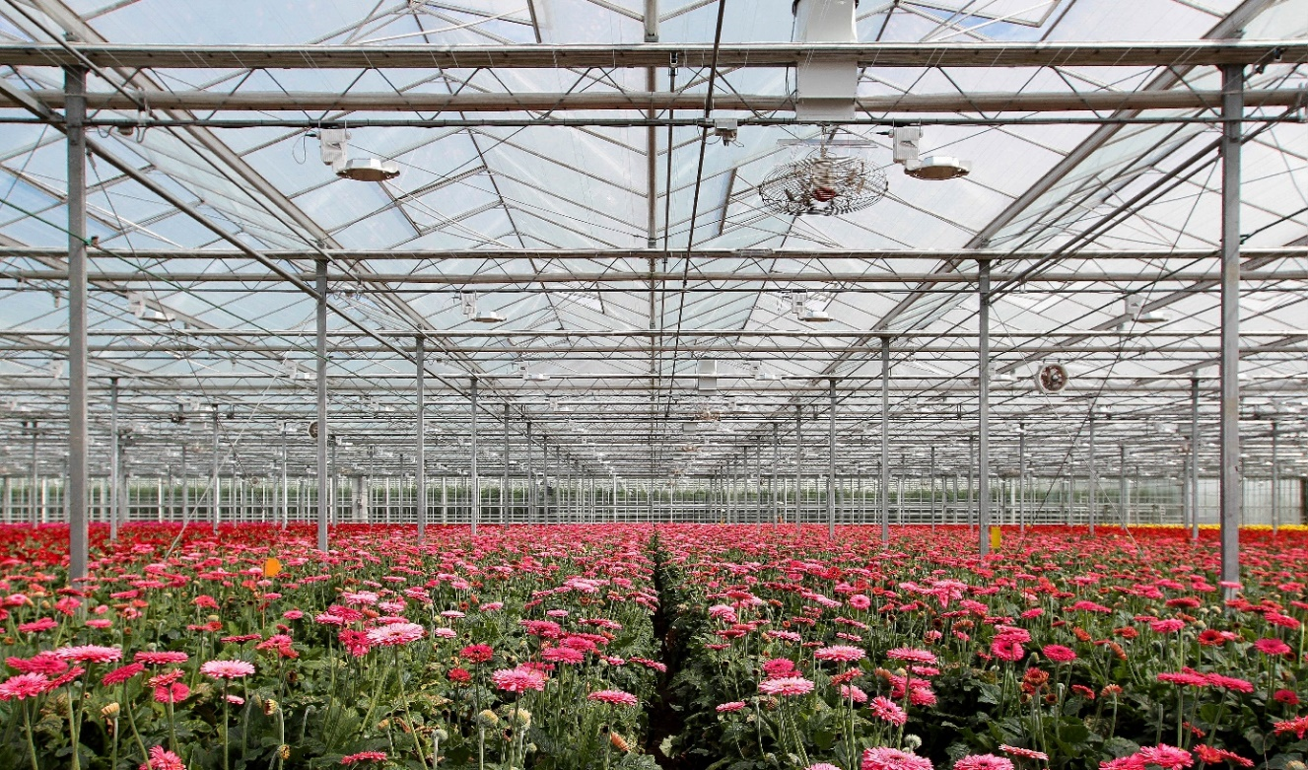
Photo: Kees Torn

Summarizing, both the airline industry and the greenhouse horticulture sector demonstrate quite a difference with the workboat industry with respect to how a business can operate in a competitive market. It has certainly a number of benefits. Let us see how similar benefits might be achieved in the international Tug and Towage industry.

Considerations for the towing industry
The two examples above certainly show a number of benefits. What has been discussed boils down to the following four characterizing elements and related factors as shown in the table below.

CHARECTERISING ELEMENTS | RELATED FACTORS
Uniformity | Design & equipment | Standardisation
 | Procedures | Maintenance
 |  | Operations
 |  | Training
Management | Fleet Management
Collaboration | Mutual cooperation | A prerequisite for innovation
 | Collaboration with research institutes and suppliers
 | Study clubs
Innovation |  | See above

Understanding the characterizing elements and related factors of the airline industry and the greenhouses house horticulture sector the question can now be asked if the towing industry should or could learn from such industry sectors. It is important when answering this question to keep in mind that nowadays changes in the modern workboat industry are happening very fast and new developments are following at a steady pace, particularly with respect to clean engines and in the field of automation which now affects many aspects of vessel design and operations. Standardization thereby becomes more of an important issue.
Another aspect to keep in mind is that the airline industry is highly standardized amongst others by governmental laws and regulations. Whether that should be desirable for certain aspects of the small-commercial-vessel industry, including tugs, could also be considered.

The idea could arise that the factors mentioned in the table above do not yet play a role in the workboat industry. That is certainly not the case. Several steps have already been taken in the past. Below are some examples.

- The European Tugowners Association (ETA) and the British Tugowners Association (BTA) work together on certain projects. Their goal is to unite and promote the interests of owners and operators of tugs (ETA) and to represent those interests of their members in order to provide a favourable commercial environment in which to do business (BTA). Nice statements, with a few amendments it will well fit within the objective of this article.
- Damen Shipyards, for example, have a high level of off-the shelf workboat concepts but engines and equipment may differ.
- Very effective collaboration may exist between research institutes and the workboat industry, where ship yards, naval architects and vessel owners, all contribute to e.g. Joint Industry Projects (JIP). For example the one initiated by MARIN in The Netherlands, called the SafeTug JIP, which focused on one specific issue, namely tugs operating at high speed in waves, as is the case with escorting, and on tugs operating at no or low speed in waves, as is the case with offshore berthing/unberthing. A wealth of interesting data has been gathered which include recommendations for tug design. See ref. [1]
A point worth considering here is that the results of JIPs are, up until now, only available to those involved in the projects. If results are not publicly available there can only be a limited effect.
- MARIN offers free tank testing for innovative ideas [9] and DNV has an Open Simulation Platform for the shipping industry [10]. Good initiatives having great potential for possible future collaboration on certain subjects.
- Some workboat companies have already started to collaborate, although more on an operational base. An example is the Fairplay Towage Group and Marine Offshore Singapore, both offering port towage services at their respective countries.

While these initiatives all have potential, for the towing companies more inspiring collaborative and innovative steps are needed. An underlying problem is, using the example made earlier, that tug designers, tug yards and towage companies differ so widely in terms of their organization, capabilities, intentions, ideas, tug design/fleet and circumstances. Keeping this in mind, let us have a look at a few possibilities that could be realized. This will be done in line with the characterizing elements and related factors as shown in the table above.

Uniformity
Nowadays there are so many different tug types; too many, it could be said. In reference [1] 15 different types are mentioned. Each type can furthermore differ in size, propulsion system, skeg configuration, deck equipment, fendering, etc. Are all these different tugs needed? The answer is simply: NO! Why then so many types? This is because there are so many ideas of what the most suitable tug might be and there is so little collaboration between towage companies and research institutes about what the best tug type is. Yes, there are variations in ports, local sea conditions and tows, but this is no reason for so many variations in tug types.

With optimum collaboration between towing companies supported by advice from maritime research institutes and if needed from shipyards and suppliers, there could be much larger uniformity in tugs and towage equipment without towing companies losing their identity. Focus could then be given to the most suitable vessel design, cleaner engines, the best fuel type, stability, deck equipment, ropes, innovation and automation, tugs working in differing sea conditions, or ice to extreme sunlight/UV, safety of operations, etc. etc. Study groups could be set up to achieve this.
In this way all can then benefit from good ideas and advice. In so doing more optimum results can be achieved, and much money can be saved. In addition, more uniformity or standardization will improve the possibilities for automation and decrease maintenance costs.

Safe procedures
Various workboat operators and organisations have safe procedures for their operations. With respect to this a good initiative has been The Workboat Association Safety Forum and its broadening embrace of the wider maritime industry and also the collaboration between ETA (European Tugowners Association) and EMPA (European Marine Pilots Association) and between Rotterdam towing companies and pilots. See ref. 4.

However, there are so many different initiatives. Would it not be much better to collaborate on one industry wide document concerning safe procedures? Hence the industry’s active relationship with IMCA and the international efforts being made to communicate with other important stakeholder associations.

Training
We now come to training, a most important subject. Again using the towage example, tug master training can be carried out by the towing company in the old but professional way, viz. training-on-the-job. Tug companies may have their own training simulator and the training-instructor is then usually one of the more experienced tug masters. Simulator institutes may also train tug masters on one of their simulators. So, there are in fact many various training systems, various training simulators, various training modules and various training-instructors.
One way to control and evidence that both the boat handling and safe management onboard (including the towage operation) competency is evident in crews is by adopting such a system as the UK MCA Voluntary Towing Endorsement scheme (see https://www.gov.uk/government/publications/mgn-468-voluntary-towage-endorsement-scheme)

Though it does not stop here. Apart from the need of a training obligation, it becomes more and more important that tug masters are appropriately and accurately trained. Tugs have grown in power and capabilities, ships and tows grow in size and complexity, safety margins are becoming smaller; tugs themselves are also becoming more complex due to the increase of computerised control systems and cleaner engines, such as dual-fuel engines, hydrogen and whole electric engines or hybrid engines, with their more complicated controls and, depending on the type of fuel, specific bunkering procedures; deck equipment requires attention due to amongst others the increase of more complicated winches and HMPE towing ropes.

Tugs will have to operate more in sea conditions such as near LNG terminals which may require additional training; not yet mentioned is the increase of automated systems on board tugs and in the wheelhouse, which also require training; risk assessments have become ever more important and should be part of the training as well as back-up systems on board and fi-fi; not to forget the essential knowledge of stability and the limitations of tugs and tug equipment, etc. Lessons learnt from accidents should be included in all training programs as a requirement. So, there are many justifiable reasons for comprehensive good training not forgetting essential training on-the-job covering tug handling and ship handling with tugs.

Instead of the present variety of training programs, would it not be time to set up professional up to date standard training schemes for tug masters which could include all the necessary aspects listed above broken down into modules which can be updated as new developments take place?
Training instructors should be of a high professional level with the required knowledge and extensive experience in handling the specific tugs they are training for.
All modern training equipment can be used, such as simulators and VR/AR systems.
Supervision and/or certification could be arranged by e.g. classification societies.

It can reasonably be anticipated that the answer to the foregoing question about a uniform professional tug master training regime is a straightforward YES. A well thought out syllabus is then needed. Now the question arises, how to set-up such a professional tug master training? Again, by proper collaboration it should be possible.

By combining the knowledge and experience of collaborating towage companies, or by creating a central study club, such professional tug master training programs can be developed, if needed with the help of training institutes, training simulator manufacturers and possibly VR/AR specialists. So, again collaboration is the answer.

Note 1:
In the near future it might become necessary to train tug masters also for remote controlling of tugs.

Note 2:
Optimisation would lead to a better understanding of the performance limits of present tug operations, which should be included in the training. The question arises who should define and guard the limitations of tug operations, where the towage industry is under pressure to speed up operations and increase e.g. the tug assistance speed beyond safe threshold limits. Through collaboration towing companies and associated companies and authorities could develop reliable functional safety standards.

Note 3:
In the foregoing, training is mainly focused on tug masters. Training for other crew members, such as engineers, and even deck hands can be arranged in a similar way.

Innovation
As already said innovation and particularly automation will work best for the industry if tugs and their equipment are more standardised. As we have seen in the greenhouse horticulture sector, collaboration is a prerequisite for innovation. If towage companies would collaborate, better results could be achieved because of the input of knowledge, experience and ideas from the whole sector.

Conclusion
The idea of closer collaboration between companies may initially give an uncomfortable feeling, with the fear of loosing identity or private ideas becoming public. There may be many reasons not to start such a collaboration and many questions may arise. However, the practical examples above show how large companies operate very well with a large level of uniformity in assets and procedures, and the same kind of companies can collaborate very well without loosing their identity. Mutual cooperation has shown many benefits, more than when staying apart.

“Coming together is a beginning;
keeping together is progress;
working together is success.”
Henry Ford

By mutual collaboration, e.g. through study clubs (think-tanks), if needed in close cooperation with research institutes, tug yards, suppliers, etc., and more standardization, the same benefits could apply to towing companies too. If that could be achieved it would then have the potency of:

- combined forces of experience, knowledge, intellect, and learning from each others failures and incidents, so achieving the best vessel design and operations;
- a higher level of practical applicability of workboat and associated equipment and of unbiased information;
- a standardized and optimum safe procedures manual;
- no loss or just limited use of bright ideas but optimum use of innovative ideas for all involved in the collaboration;
- an increased level of standardization of workboats and their equipment, thus
- creating a situation where innovation and automation processes can better be implemented and realized faster; and
- maintenance be more standardized and at lower costs;
- creating a higher level of professional training for tug Masters and Engineers, standardized and attuned to the various operation types and the requirements of present and future modern fleets and operations.
- In summary, the effect of more collaboration and standardization is higher standards and lower company costs. It may even lead to acceptable tariffs.

Are these not all good reasons to start such a new culture of collaboration within the workboat industry? Collaboration starts often on a low level, from local communities (regionally), to nationwide, but can become wider e.g. across Europe and even worldwide, between companies that fit best with each other. Collaboration can focus on all the aspects addressed above or just on some of them but in doing so the whole sector can derive benefits. Some initiatives have already been taken as has been mentioned in the former paragraph.

The question was: `Collaboration in Workboat World. Wanted and Needed?’ That it is needed has clearly been shown in this article. The question remains if a closer collaboration between the wider workboat industries is indeed wanted. If wanted, who takes the initiative to see the first steps towards making this idealism a reality?

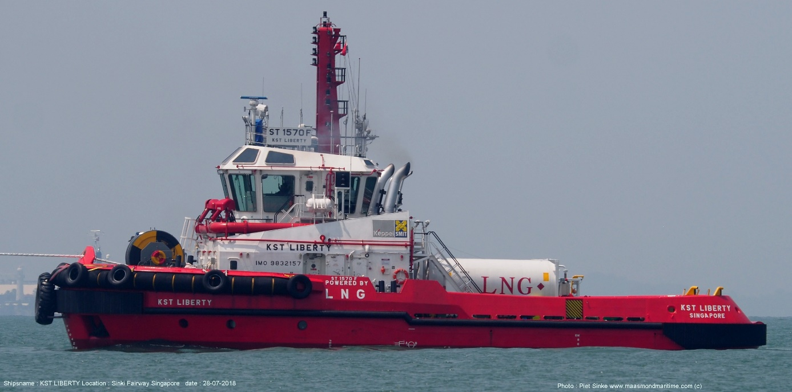
Photo: Piet Sinke

Finally
The above focuses on the great benefits of collaboration and standardisation. The workboat industry is very diverse. For that reason the towing industry, as part of the workboat industry, is used in this article as example. It will have become clear that many aspects of what has been discussed about the Tug and Tug World applies to other sectors of the workboat industry as well.

References:
[1] Tug Use in Port. 3rd edition. Captain Henk Hensen. The ABR Company UK. 2019.
[2] The Maritime Executive. July-August 2019. Page 68-72. Charlie Bartlett.
[3] The road towards autonomous ship handling with tugs and practical issues to solve. Henk Hensen, Johan de Jong, Markus van der Laan en Daan Merkelbach. https://www.swzmaritime.nl/news/2019/07/11/the-road-towards-autonomous-ship-handling-with-tugs/ 2019.
[4] Joint ETA-EMPA guidelines on design and layout of harbour towage equipment. 2011. http://eurotugowners.com/wp-content/uploads/2017/11/110215-Best-Pract-Final-Rev-11.pdf
[5] Report on Safe Tug Procedures. 2013. https://www.nvkk.nl/files/6113/6689/0145/Summary_All_Questionnaires_Final_version.pdf
[6] Bevlogen onderhoud. Dr.ir. Jaap van Ede. 30-06-2010
[7] Glastuinbouw als succesvoorbeeld van innovatie en samenwerking. Eduard Voorn. 31 March 2017.
[8] This tiny country feeds the world. National Geographic Magazine. September 2017.
[9] Wederom gratis MARIN testtijd voor maritieme MKB’ers in 2020.
[10]The pros of an open simulation platform in shipping industry. Smart 12/11/19.

